Exercise 5: Return Data from a Stored Procedure
Goal: Create a stored procedure that returns the total number of employees in a department. This is simulated using a MySQL query in DB Fiddle, since stored procedures are not supported there.

Step 1: Description
This SQL query simulates a stored procedure by taking a department ID (for example, 3 for IT) and returning the number of employees in that department.

Step 2: SQL Query
SELECT D.DepartmentName, COUNT(E.EmployeeID) AS TotalEmployees
FROM Employees E
JOIN Departments D ON E.DepartmentID = D.DepartmentID
WHERE E.DepartmentID = 3;

Step 3: Output
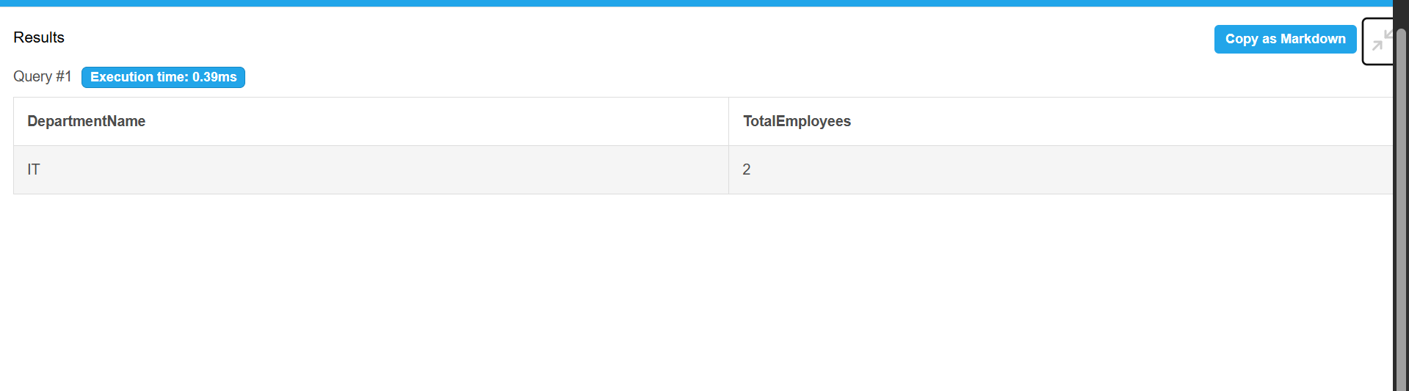

Step 4: Explanation
This query joins the Employees and Departments tables using the DepartmentID column. It filters the result for DepartmentID = 3, which corresponds to the IT department, and uses the COUNT() function to return the total number of employees in that department.

